2 *2 Matrix Class.
For this task, put your code in the following files: Matrix.cpp, Matrix.h. You are to write a class Matrix which includes appropriate fields associated with 2*2 matrices. A 2*2 matrix takes the following form:
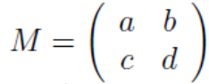 (where a, b, c and d are real numbers)
Your Matrix class must have the following features:
- When a matrix object is created, it should be initialized to the identity matrix. The identity matrix has the following form: 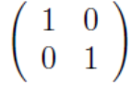
- Overload the insertion operator to display the contents of the matrix in the following form: 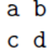
- Overload the extraction operator to take four real numbers to fill the contents of the matrix. The four numbers will be in sequence: a b c d
- Overload the binary +, -, and * operators to perform matrix addition, subtraction and multiplication. These calculations all result in a 2 _ 2 matrix, as shown below:
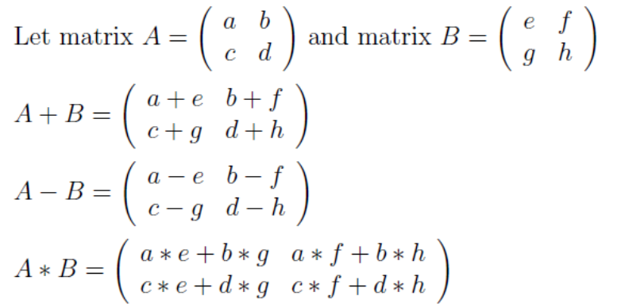

These operations must be chainable (e.g. A + B + C).

- Overload the +=, -=, and *= operators, as member functions of class Matrix.
- Overload the * operator to perform scalar multiplication, as shown below:
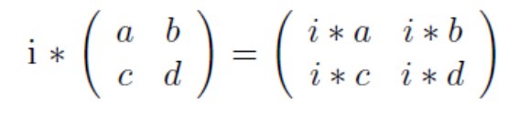
- Overload the equality and inequality operators to compare two matrices.
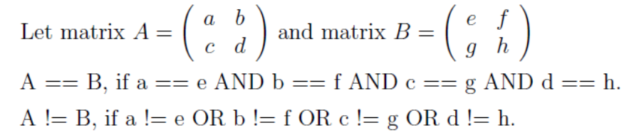
Use the main function provided in MatrixMain.cpp to test your Matrix class.

